**Project Development Phase**

**Model Performance Test**

|  |  |
| --- | --- |
| Date | 15 November 2022 |
| Team ID | PNT2022TMID00397 |
| Project Name | Project - Intelligent Vehicle Damage  Assessment & Cost Estimator for Insurance Companies |
| Maximum Marks | 10 Marks |

**Model Performance Testing:**

Project team shall fill the following information in the model performance testing template.

|  |  |  |  |
| --- | --- | --- | --- |
| **S.No** | **Parameter** | **Values** | **Screenshot** |
| 1. | Model Summary |  | **Damage in the Body:**    **Level of Damage:** |
| 2. | Accuracy | **Damage in the Body:** Training Accuracy - 93.28%  Validation Accuracy -  89.31%  **Level of Damage:**  Training Accuracy - 92.47%  Validation Accuracy - 89.31% | **Damage in the Body:**    **Damage in the Body:** |

**Model Summary:**



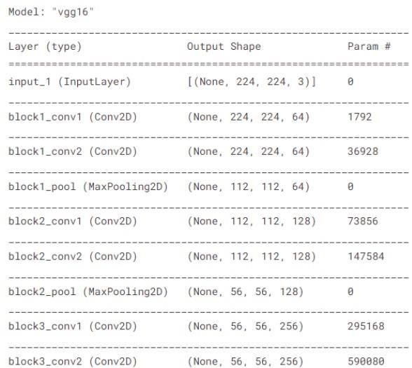

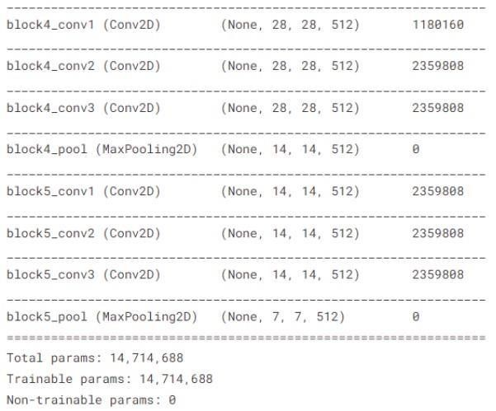

**Accuracy: 1) Body of Damage:**

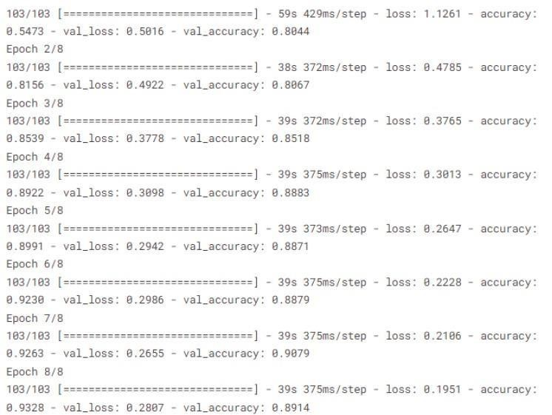

**2) Level of Damage:**

